**GROUP 5: RESEARCH REPORT**

**(Pills on Track)**

**(1) GENERAL RESEARCH STRATEGY/APPROACH/TECHNIQUES:**

We used contextual inquiry to interview grandparents who are a part of the targeted user population for our app. Additionally, we interviewed a younger user of Amazon Pharmacy, which delivers medication, to provide details about the acquisition/delivery of medication and help us think about how our app should run to handle different scenarios of use (normal, emergency). A brief competitor analysis of similar medical reminder apps was done to help us assess what features and functions our app should include.

**(2) RESEARCH AND OUTPUT:**

**Task analysis of the current Amazon Pharmacy system discovered via contextual inquiry from an Amazon Pharmacy user:**

[(LINK to zoomable image)](https://drive.google.com/file/d/1A9mKd3UdnG4hceUxV_Ty55C5W0PxNs5Y/view?usp=sharing)

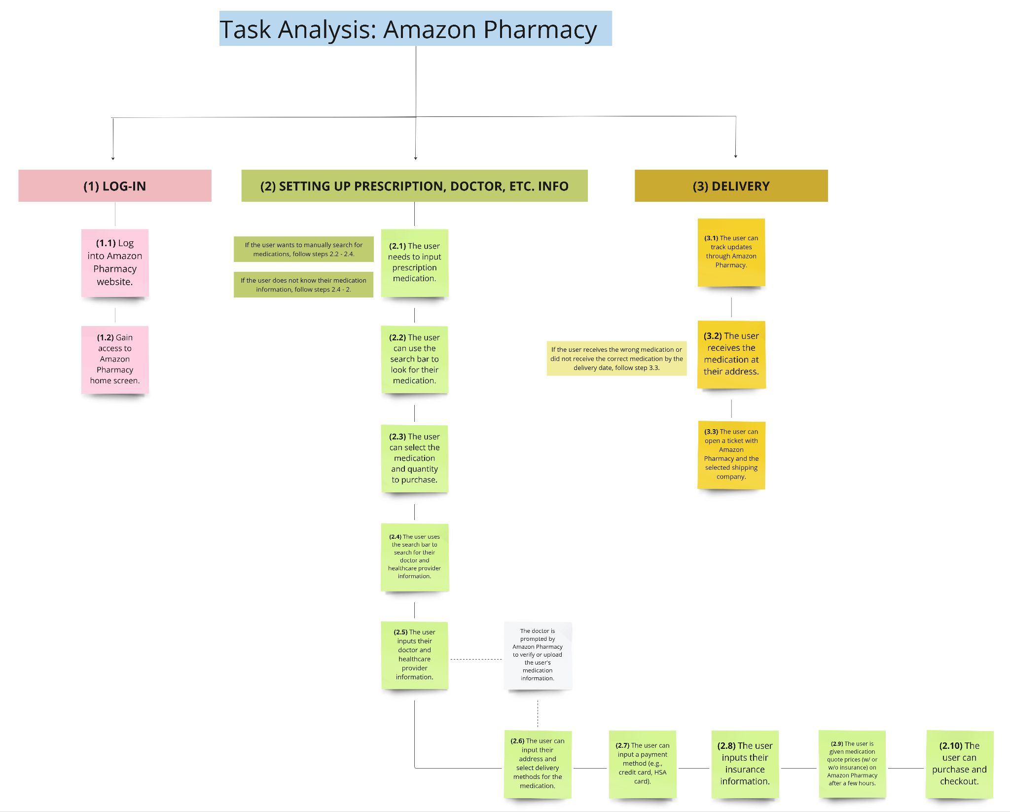

Some other features to consider that were mentioned by the interviewee: The user can buy their medication whenever they need it, but there are limitations set to how much medication they can buy by the nature of the prescription and medicine type (e.g., once a month). They can add the medication to their cart and choose either to purchase with or without insurance.

The interviewee also mentioned a recent problem she encountered with Amazon Pharmacy when her medication was not delivered on time. Upon checking the USPS website, she found that she would have to pick up the medication instead, despite no delivery person ever arriving at her home or attempting a delivery. She had to then open a ticket with Amazon Pharmacy, who asked her to talk to USPS first, to have it redelivered. Eventually, it was redelivered within a few business days.

**Scenarios created based on user interviews of people above the age of 60 who take medications on a regular basis:**  (For exact interview please refer the glossary section of this document)

As-is: Scenarios for medicine consumption without the app’s assistance

1. User is reminded by family members to take the medicines
2. User has the medicines delivered to them or in some cases picks it up themselves
3. User carries the medication with them at all times
4. User receives packed medications from the pharmacy as per dosage
5. User is able to read medical prescriptions and take the pills correctly
6. User is not able to read medical prescriptions
7. User is not comfortable with using technology devices

To-be: Scenarios for medicine consumption with the app’s assistance

1. User should be able to inform the app that the medication has been taken
2. User should be guided by the app via visual descriptions about the medication to be taken
3. App should remind the user to take the medicines using descriptive messages and alerts either via text, voice or wearable gear
4. App should notify the user about the medication being delivered via either text messages/ in-app notifications / phone call/ wearable gear
5. App should be able to check on the users if they are taking medications properly and accept user feedback.

The collective pool of these scenarios has given us an insight into a complete set of features that our app should accommodate. The ‘as-is’ scenarios mentioned above are not all integrated in a technological platform. Our app will aim to account for all of these suggested features and some potential improvements.

**Competitor analysis:**

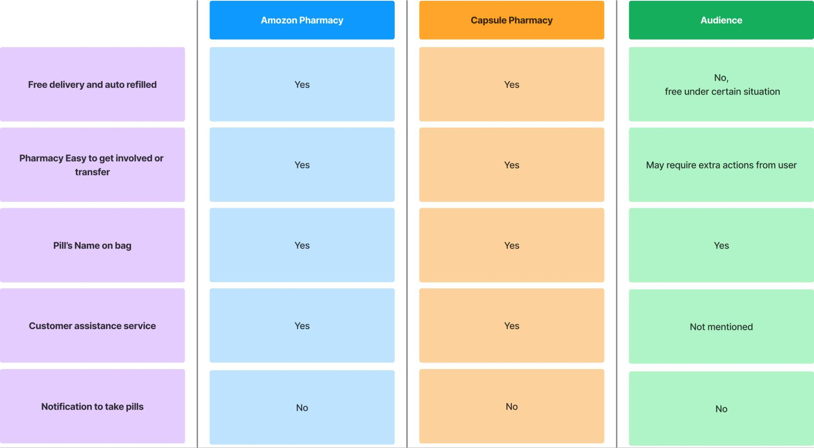

**In both Amazon Pharmacy and Capsule Pharmacy**

1. You don’t need to register, the doctor will inform the pharmacy and the pharmacy will set up everything and text you. And both Amazon and Capsule would make sure the transfer would be done in a short time period.
2. Free delivery, need someone to receive and sign for the medicine.
3. Pharmacy would keep track with doctors and insurance companies to make sure the refill is on time

**(3) KEY CONCLUSIONS/INSIGHTS:**

Our research has led us to gather the following insights:

1. The app can have a similar support or contact feature as that of Amazon pharmacy, not only with the pharmacy, but also with their healthcare provider or doctor. This feature can be used if there is an issue with or the user has questions about their medication.
2. Prioritize the design to focus on the ease for users to onboard and engage with the App.
3. Prioritize the ease for users to receive reminders.
4. App should have a convenient user interface to account for technological accessibility for people above 60 years of age.
5. User pool may have different requirements about how they want the app to engage with them (via text, call, wearable devices, voice messages, etc). The app should be able to provide sufficient support to accommodate preferences of all users.
6. App should provide some flexibility for users to set some preferences about receiving reminders

**(4) LIMITATIONS/CONSIDERATIONS OF FAILURE:**

* **Shipping errors:** In considering potential emergency scenarios (such as the wrong medication is delivered, the correct medication is not on time, or the incorrect medication is taken), the pharmacy or shipping company may make mistakes which take an unspecified amount of time to rectify.
* **Integration with the US Healthcare Providers:** It would be difficult to have our app synchronize with U.S. healthcare providers so that a patient’s medication information is automatically transferred to the app to avoid manually inputting information for older adults.
* **User testing and feedback:** We would like to interview more users from our target population and see how older adults would react to interacting with the Amazon Pharmacy and Pill Pack website interfaces, and the PillBox reminder app interface.
* **User adoption:** Considering out target population is 60+, it might be challenging to convince them to use a new technology as they might be resistant to change.
* **Medical updates:** Ensuring that the medical records of the users are frequently updated within the app might be challenging, this can impact the medicine consumption dosage and health of the users.

**(5) AREAS OF RESEARCH IF WE HAD ADDITIONAL TIME:**

1. We would interview the caretakers of the target population of our app to better understand the challenges they face in making timely medication available to our target population.
2. We would interview an extended pool of adults of age below 60 to understand the differences in user preferences and behaviors.
3. We would like to research the challenges from the health professionals’ and pharmacies’ perspective to be able to support an app like this since our solution currently assumes that patient profile set up and prescription details will be uploaded by the doctor’s clinic.

**GLOSSARY:**

**Interview #1**

**Interview with Vanshika’s grandparents:**

**Contextual Inquiry based:**

1. **How do you typically spend your day, and what activities are most important to you?**

We get up in the morning, have some tea and toast and go for a long walk. We love being physically active and hence go for walks lasting 1-2 hours. Then come back and have fruits and cereals.

1. **What types of technology devices do you use regularly (e.g., smartphones, computers, tablets)?**

We use smartphones a lot and also computers to manage some of our bills and other documentations.

1. **How comfortable do you feel using technology and the internet in your daily life?**

Quite comfortable

1. **How do you currently manage your medications? Can you walk me through your daily routine in this regard?**

We take medicines some in the morning and some at night. We mostly remember taking them timely, if not then one person reminds the other to take.

1. **How do you currently obtain your medications? Do you pick them up from a pharmacy, have them delivered, or use a different method?**

Most of them are delivered from our healthcare insurance United Healthcare. They get them delivered to our house through the pharmacy company that is in partnership with them. Sometimes we pick any urgent medications from the pharmacy.

1. **When you're not at home during medication times, do you carry your medications with you?**

Yes we carry our medication box everywhere we go.

1. **Have you ever experienced confusion or uncertainty when it comes to the names and doses of your prescribed medications?**

Doses are prescribed by the doctor, pharmacy company sends dosage wise medicines. Instructions are written on the container and are self-sufficient. We never really are confused about the medicine and their time as everything is mentioned in the box that is delivered to us.

1. **Have you ever used any digital tools or apps to assist with medication reminders?**

No, we try to remember everything or our family members remind us as they are aware of

our medication schedule.

**Scenario-based:**

1. **Are you familiar with or have you ever used services like PillPack (medication delivery) or PillBox (medication reminder app)?**

Yes we are aware, but have never used it. We use our insurance company’s delivery system.

1. **In case you take the correct medication but at the wrong time, how should the app help you make corrections and ensure you maintain the prescribed schedule?**

The app can monitor or give us tasks before we consume the medication. After consuming we can enter the time and name of the medicine to complete the task. If observed that the timing does not match the medication schedule then they can send alert or notify about the incorrect medication schedule.

1. **Do you believe that visual aids, such as images or descriptions of medications, could be beneficial within the app to help you recognize and differentiate them?**

Yes definitely. Visuals always help. Though we can read well but later on in case there is some challenge in reading the instructions clearly then having pictures of the medicines and the steps to consume can help a lot of older adults.

1. **How do you feel about having the option to listen to the instructions using voice-based assistance, especially if reading is a challenge?**

Voice-based or having someone calling us is a good option. As long as they can do this timely according to our medication schedule.

1. **How do you prefer the app to remind you of your medications or delivery?**
   1. **In-app notifications**
   2. **Phone call**
   3. **Text message –** Would prefer a simple text message
   4. **Email**
   5. **Wearables like smartwatches or fitness trackers –** This is nice to have
2. **Can you suggest any additional features or considerations that would enhance your experience with medication instructions in the app?**

Someone calling every week and checking if we are following our medication schedule properly. And also taking feedback on the delivery process very often.

**INTERVIEW #2**

(Interview with Ruchika’s grandmom)

Questions:

1. How many times a day do you take medicines?
   1. 3 times
2. Who reminds you to take the medicines?
   1. My daughter gives me the medicines
3. Do you remember to take the medicines in the absence of your daughter?
   1. Yes
4. Do you know when to take which medicine?
   1. Yes, my daughter has arranged it in a pill box for me. I just follow the pill box.
5. Will you be able to take the medicine in the absence of the pill box?
   1. No
6. If your phone is to remind you to take medicines, will you use such a feature?
   1. Maybe
7. Do you think it will help somebody of your age who is living by themselves?
   1. Phone is confusing to use, so maybe not so much
8. If the phone will tell you automatically which color and shape of medicine should be taken at the correct time, will you be able to identify it?
   1. Yes
      1. Will you use the feature in this case?
         1. Yes
9. What factors help you identify a medicine? Is the shape and color enough?
   1. Yes but sometimes it's necessary to mention size as well, I have 2 white round medicines of different sizes.
10. Would you prefer the phone to remind you, a phone call to remind you or a watch-like strap to remind you about the medicine?
    1. I would prefer a phone call.
11. Is there any additional information you would like to know during the reminders?
    1. No, color shape and size seems enough.

**INTERVIEW #3**

(Interview with Amazon Pharmacy user)

I conducted an interview with my sister in which she showed me how the Amazon Pharmacy website works and explained to me how she gets her medication delivered to her. This interview will help provide context about how our app should function and what the standard procedure is from a company that has an established online medication delivery process.